General Shade Specifications
- 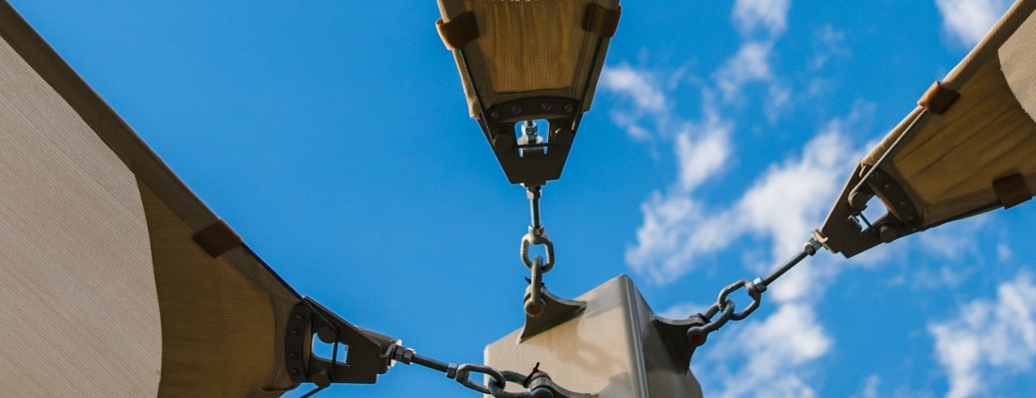

Fabric Specifications
- UV shade fabric is made of UV stabilized cloth manufactured by ALNET, or approved equal.
- The high-density polyethylene material shall be manufactured with tensioned fabric structures in mind.
- The fabric knit is to be made using monofilament and tape filler which has a weight of 9.38 to 10.32 oz. sq. yd. Material to be Rachel-knitted to ensure material will not unravel if cut.
- Burst strength of 828 lbf (ASTM 3786).
- Cloth meets fire resistance tests as follows:
  - Alnet Extra Block: California State Fire Marshall Reg. #F-93501
  - Others: NFPA 701-99 (Test Method 2), ASTM E-84
- Fabric Properties:
- Stretch/Stentored
- Tear Tests (lbs/ft): WARP 44.8 and WEFT 44
- Burst Tests (lbs ft): 828
- Fabric Weight (oz/sqFT) Average: 1.02 to 1.07
- Fabric Width: 9’-10”
- Roll Length: 150’
- Roll Size: 63” x 16.5”
- Weight: 120 lbs.
- Life Expectancy: 10 years
- Fading: Minimum fading after 6 years (Note: 3 years for Red and Yellow)
- Temperature: -77 degrees
- Maximum Temperature: +167 degrees

Thread
- Shall be 100% expanded PTFE fiber which carries a 10-year warranty that is high strength and low shrinkage.
- Shall have a wide temperature and humidity range.
- Abrasion resistant and UV radiation immunity.
- Shall be unaffected by non-hydrocarbon based cleaning agents, acid rain, mildew, rot, chlorine, saltwater, and pollution.
- Lockstitch thread – 1200 Denier or equal.
- Chain stitch thread – 2400 Denier or equal.

Steel Tubing
- All fabricated steel must be in accordance with approved shop drawings and calculations.
- All steel is cleaned, degreased or etched to ensure proper adhesion of powder-coat in accordance with manufacturer’s specifications.
- All Steel used on this project needs to be new and accompanied by the mill certificates if requested. Structural steel tubing up to 5”-7 gauge shall be galvanized per Allied Steel FLO-COAT specifications. Schedule 40 black pipe fabrications shall be sandblasted and primed as described below.
- All non-hollow structural shapes comply with ASTM A-36, unless otherwise noted.
- All hollow structural steel shapes shall be cold formed HSS ASTM A-53 grade C, unless otherwise noted.
- Plate products shall comply with ASTM A-36.

Superdurable Powder Coating and Priming
- All non-galvanized steel shall be sandblasted and primed prior to powder coating using brown fused aluminum oxide grit and the following primer.
- All non-galvanized steel must be coated with rust inhibiting primer prior to applying the powder coat. Primer shall be Marine Grade Cardinal Industrial Finishes Corp. E396 – GR1372 epoxy powder coating semi-gloss smooth zinc rich primer.
- Welds shall be primed with rust inhibiting primer prior to applying the powder coat. Primer shall be Marine Grade Cardinal Industrial Finishes Corp E396-GR1372 epoxy powder coating semi-gloss smooth zinc rich primer.
- All steel parts shall be coated for rust protection and finished with a minimum 3.5 mil thick UV-inhibited weather resistant powder coating.
- Powder used in the powder-coat process shall have the following characteristics:
  - N.3.1 | Specific Gravity | 1.68+/-0.05
  - N.3.2 | Theoretical Coverage | 114+/-4 ft. 2/lb/mil
  - N.3.3 | Mass Loss During Cure | <1%
  - N.3.4 | Maximum Storage Temperature | 75˚ F
- Powder-coating shall meet the following tests:
  - ASTM | Gloss at 60° | 85-95
  - HOI TM 10.219 | PCI Powder Smoothness | 7
  - ASTM D2454-91 | Over-Bake Resistance Time | 200%
  - ASTM D3363-92A | Pencil Hardness | H-2H
  - ASTM D2794-93| Dir/Rev Impact, Gardner | 140/140 in./lbs.
  - ASTM D3359-95B | Adhesion, Cross Hatch | 5B PASS
  - ASTM D522-93A | Flexibility Mandrel | ¼” Diameter, No Fracture
  - ASTM B117-95 | Salt Spray | 1,000 Hours
  - UL DtOV2 | Organic Coating Steel Enclosures, Elect Eq. | Recognized
- Application Criteria:
  - N.5.1 | Electrostatic Spray Cold | Substrate: 0.032 in. CRS
  - N.5.2 | Cure Schedule | 10 Minutes at 400° F
  - N.5.3 | Pretreatment | Bonderite 1000
  - N.5.4 | Film Thickness | 3.5 Mils

Welding
- All shop welds shall be executed in accordance with the latest edition of the American Welding Society Specifications.
- Welding procedures shall comply in accordance with the AWS D1.1-AWS Structural Welding Code-Steel.
- All welds to be performed by a certified welder. All welds shall be continuous where length is not given unless otherwise shown or noted on drawings.
- All welds shall develop the full strength of the weaker member. All welds shall be made using E70xx.035 wire.
- Shop connections shall be welded unless noted otherwise. Field connections shall be indicated on the drawings. Field –welded connections are not acceptable.
- All fillet welds shall be a minimum of ¼” unless otherwise noted.
- All steel shall be welded shut at terminations to prevent internal leakage.
- Internal weld sleeving is not acceptable.
- On-site welding of any component is not acceptable.

Sewing
- On-site sewing of a fabric will not be accepted.
- All corners shall be reinforced with extra non-tear cloth and strap to distribute the load.
- The perimeters that contain the cables shall be double lock stitched.

Stainless Steel Hardware
- Bolt and fastening hardware shall be determined based on calculated engineering loads.
- All bolts shall comply with SAE-J429 (Grade 8) or ASTM A325 (Grade BD). All nuts shall comply with ASTM F-594, alloy Group 1 or 2.
- Upon request, Stainless Steel hardware shall comply with ASTM A-304.
- 1/4” galvanized wire rope shall be 7x19 strand with a breaking strength of 7,000 lbs. for shades generally under 575 sq. ft. unless requested larger by the customer. For shades over 575 sq. ft., cable shall be 5/16” with a breaking strength of 9,800 lbs. Upon request, 1/4” Stainless Steel wire rope shall be 7x19 strand with a breaking strength of 6,400 lbs. 5/16” Stainless Steel wire rope shall be 7/19 strand with a breaking strength of 9,000 lbs.
- All fittings required for proper securing of the cable are hot dipped galvanized.

Concrete
- Concrete work shall be executed in accordance with the latest edition of American Concrete Building Code ACI 318 unless specified by the governing municipality.
- Concrete specifications shall comply in accordance with, and detailed as per plans as follows:
  - 28 Days Strength F’c = 2500 psi
  - Aggregate: HR
  - Slump: 3-5
  - Portland Cement shall conform to C-150
  - Aggregate shall conform to ASTM C-33
- All reinforcement shall conform to ASTM A-615 grade 60.
- Reinforcing steel shall be detailed, fabricated and placed in accordance with the latest ACI Detailing Manual and Manual of Standard Practice.
- Whenever daily ambient temperatures are below 80 degrees Fahrenheit, the contractor may have mix accelerators and hot water added at the batch plant (See Table 1).
- The contractor shall not pour any concrete when daily ambient temperature is below 55° F.
Temperature Range | % Accelerator | Type Accelerator
75-80° | 1% | High Early (Non-Calcium)
70-75° | 2% | High Early (Non-Calcium)
Below 70° | 3% | High Early (Non-Calcium)

Footings
- All anchor bolts set in new concrete shall be ASTM A-307, or ASTM F-1554 if specified by engineer.f
- All anchor bolts shall be zinc plated unless specified otherwise.
- Footing shall be placed in accordance with and conform to engineered specifications and drawings.

